Briefing on Malaysian Government's Failure to Combat Organized Crime Networks Trafficking Bangladeshi Migrants into Forced Labour

Submitted by: Migrant Workers Rights Specialist Mr. Andy Hall

November 2023



Caption: Destitute and unemployed workers from Bangladesh living in unsanitary conditions in Malaysia (Nov 2023).

Briefing on Malaysian Government's Failure to Combat Organized Crime Networks Trafficking Bangladeshi Migrants into Forced Labour 1
1. Background 3
2. Identified Victims of Human Trafficking 4
3. Primary Victims of Syndicate: Case Examples 5
4. ILO Indicators of Forced Labour 9
5. Forced Labour and Money Laundering 9
6. Organized Crime (UNTOC) 10
7. Bangladeshi and Malaysian Government's Responses 10
8. Complaint to OHCHR Special Procedures 11
9. Non-Governmental and UN Agency Responses 12
10. Challenges Identifying Victims of Human Trafficking in Malaysia 12
11. Recommendations for Immediate Action 12

Background

Malaysia reopened its labour market to Bangladeshi migrant workers travelling into the country on December 19th 2021. Bangladeshi worker’s labour migration actually resumed to Malaysia on August 9th 2022, ending a three-year embargo. Previous Malaysian administrations ordered suspension of migration between Bangladesh and Malaysia most recently in September 2018 due to malpractice, high recruitment costs, bogus employers and other irregularities impacting vulnerable workers. There have been five separate suspensions by Malaysia's government of labour migration from Bangladesh into the country in recent years. All of these suspensions stemmed from allegations of exploitation.

The exploitative labour migration corridor from Bangladesh to Malaysia has for a long time been associated with an alleged syndicate that facilitates movement of workers at high cost between the two countries. A “syndicate” is a common word used in Asia to describe a group of individuals or organisations combined to promote a common interest, with the intention of unfairly controlling some market or activity. In this case, the common interest of the syndicate is to unreasonably profit from impoverished migrant workers traveling from Bangladesh to Malaysia in search of employment.

The syndicate discussed in this briefing paper involves Bangladeshi manpower agents and subagents, Malaysian intermediaries, Malaysian outsourcing agents, Malaysian employers and Bangladeshi and Malaysian government officials. A few syndicated manpower agencies and individuals in both countries bypass the majority of registered manpower agencies and actors involved in recruitment in Bangladesh and Malaysia. This briefing cites media reports of various names associated with this syndicate.

This syndicate stands accused of engaging in various illicit activities, including exorbitant migration fees charged by the syndicate’s actors, money laundering, organized crime, forced labour, human trafficking, and as a result, labour exploitation and other rights abuses impacting on its vulnerable victims.

Despite ongoing protests by Bangladeshi manpower agencies and continual suspensions in migration between Bangladesh and Malaysia occurring over the years, this alleged syndicate continues to operate leading to exorbitant migration expenses including high recruitment fees charged to migrant workers and highs costs associated with accommodation, flights, food and medical expenses. Moreover, this has led to the perpetuation of systematic forced labour and debt bondage for the victims.

There is evidence of workers from India, Indonesia, Myanmar and Nepal facing similar situations of exploitative recruitment and destitution in Malaysia at this time due to unethical and irregular recruitment practices. However, because of similar challenges faced by Bangladeshi workers, this briefing focuses only on the plight of Bangladeshi workers due to the more systematic and syndicated nature of this migration corridor and the considerably higher recruitment fees and levels of debt bondage involved.

Identified Victims of Human Trafficking
A comprehensive collection of case studies documenting the situation of workers from Bangladesh who have fallen victim to this syndicate recently has been compiled by a team supporting independent migrant worker rights activist Andy Hall since mid-2022. These case studies, documented following worker complaints, have been submitted to all pertinent stakeholders, including the governments of Bangladesh and Malaysia, the Bangladeshi Embassy in Kuala Lumpur, UN agencies (IOM and ILO), local NGOs, and trade unions (MTUC, Tenaganita, and NSI), and various media outlets.

Workers from Bangladesh migrating to Malaysia face exorbitant migration costs charged by recruitment agencies that are part of the syndicate in Bangladesh, facilitating their migration to Malaysia, ranging from 450,000 BDT to 550,000 BDT (4,000 USD to 5,000 USD). This cost is 5 to 7 times higher than the standard migration cost of 78,990 BDT (about 700 USD) announced by the Bangladeshi government. These costs generally have to be paid in advance of migration, and considerable sums of money are often borrowed at high interest to cover these costs.

False job promises lure many low-skilled migrants from impoverished backgrounds in Bangladesh. Subsequently, they find themselves trapped in debt bondage to cover the exorbitant costs of their migration and the increasingly difficult interest payments they have to cover.

Despite paying substantial fees, the various actors involved in the syndicate deny promised benefits and subject migrant workers to inhumane treatment upon reaching Malaysia. Furthermore, their passports are confiscated at the airport upon arrival, rendering them undocumented, indicating a situation of forced labour. In other instances, migrant workers' temporary e-visas expire, placing them in vulnerable situations at the hands of those within the syndicate. Therefore, this leaves migrant workers vulnerable to cramped and unsanitary living conditions, inadequate access to water, and insufficient food. Some are even locked out of their accommodations by syndicate actors when they complain or once its clear no jobs are available for them on arrival, or forced by outsource agents, also part of the syndicate, to reside in precarious jungle dwellings that are susceptible to floods and wildlife attacks. With no knowledge of the whereabouts of their passports, these workers face detention by law enforcement officials due to lack of documentation.

Case studies allege that some Malaysian employers also demand 3,700 RM to 6,000 RM from workers to return their passports, prompting some workers to take out more loans to get their passports and flee their situation of deprivation. Many others flee without their passports. Moved without consent, many victims of the syndicate are waiting for jobs for up to 6 months. Some workers end up with a job where they experience terrible working conditions and non-payment of wages for months. Workers subsequently accumulate higher interest rates and deeper debt bondage as their original loan for their unsuccessful migration continues to increase in Bangladesh.

Between August 2022 and August 2023, 314,481 Bangladeshi workers migrated to Malaysia. Conversely, Malaysia is grappling with over 250,000 excess migrant labourers. The oversupply issue results from a lack of attention from Malaysian authorities and source country Embassies in approving migrant quotas and verifying job authenticity for bogus employers when there is no work. Many fake employers bring in workers to operate as outsource agents, sending these workers to workplaces of employers when there is a labour need. Outsourcing has been illegal in Malaysia since March 2019.

Primary Victims of Syndicate: Case Examples
Recent investigations have uncovered numerous cases of exploitation and abuse involving migrant workers in Malaysia brought in from Bangladesh through the syndicate outlined above. A few cases are outlined below, and illustrated costs are shown in the table. All of these cases was collected by teams assisting migrant worker rights specialist Andy Hall.

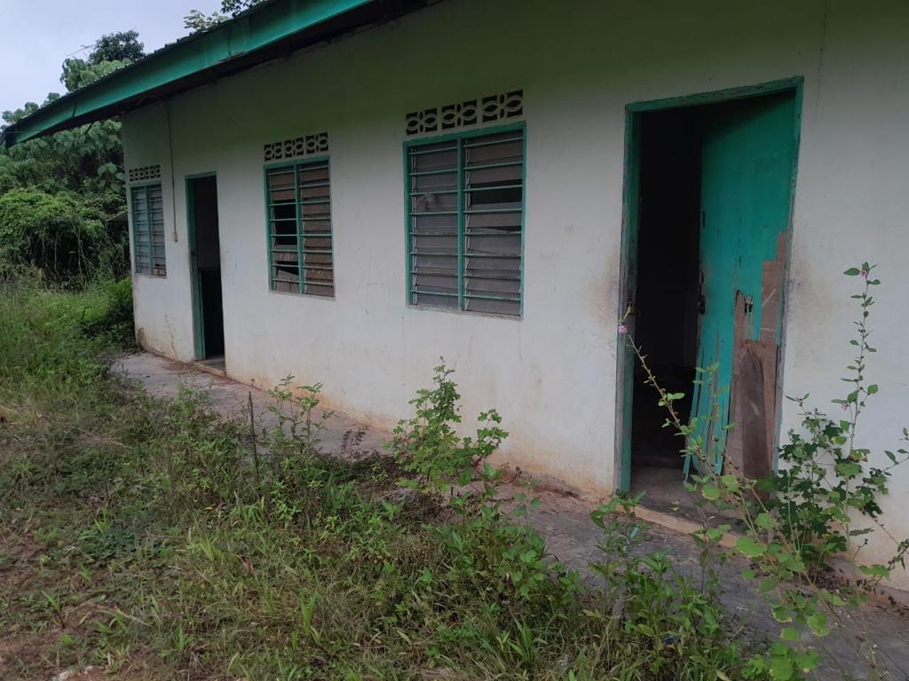
One such case involves hundreds of Bangladeshi workers recruited by a company, Suria Harmoni, who find themselves unemployed and cramped in overcrowded accommodations in the Chawkit area in the centre of Kuala Lumpur's historical district. Their passports have been confiscated, and despite being promised jobs within a few days of arrival, these jobs never materialize, leaving the workers trapped in debt bondage, unable to move freely, indicating a violation of Article 13 UDHR, right to freedom of movement and Article 23 UDHR, right to work, to free choice of employment, to just and favourable conditions of work, and to protection against unemployment. Some workers moved between different locations, enduring deplorable living conditions without proper amenities, indicating a violation of Article 3 UDHR, right to life, liberty, and security. Poor accommodation has led many to fall sick, indicating a violation of Article 5 UDHR; no one should be subjected to torture or cruel, inhuman, or degrading treatment or punishment. When the workers request their passports, the employer allegedly demands a payment of 6500 RM, exemplifying the exorbitant migration costs referred to above. While a few workers manage to pay this amount to returners, most cannot. As a result, their debts worsen, leading to threats and assaults from money lenders and causing financial hardships for their families, including disruptions to their children's education, indicating a violation of Article 20 UDHR, right to an education.

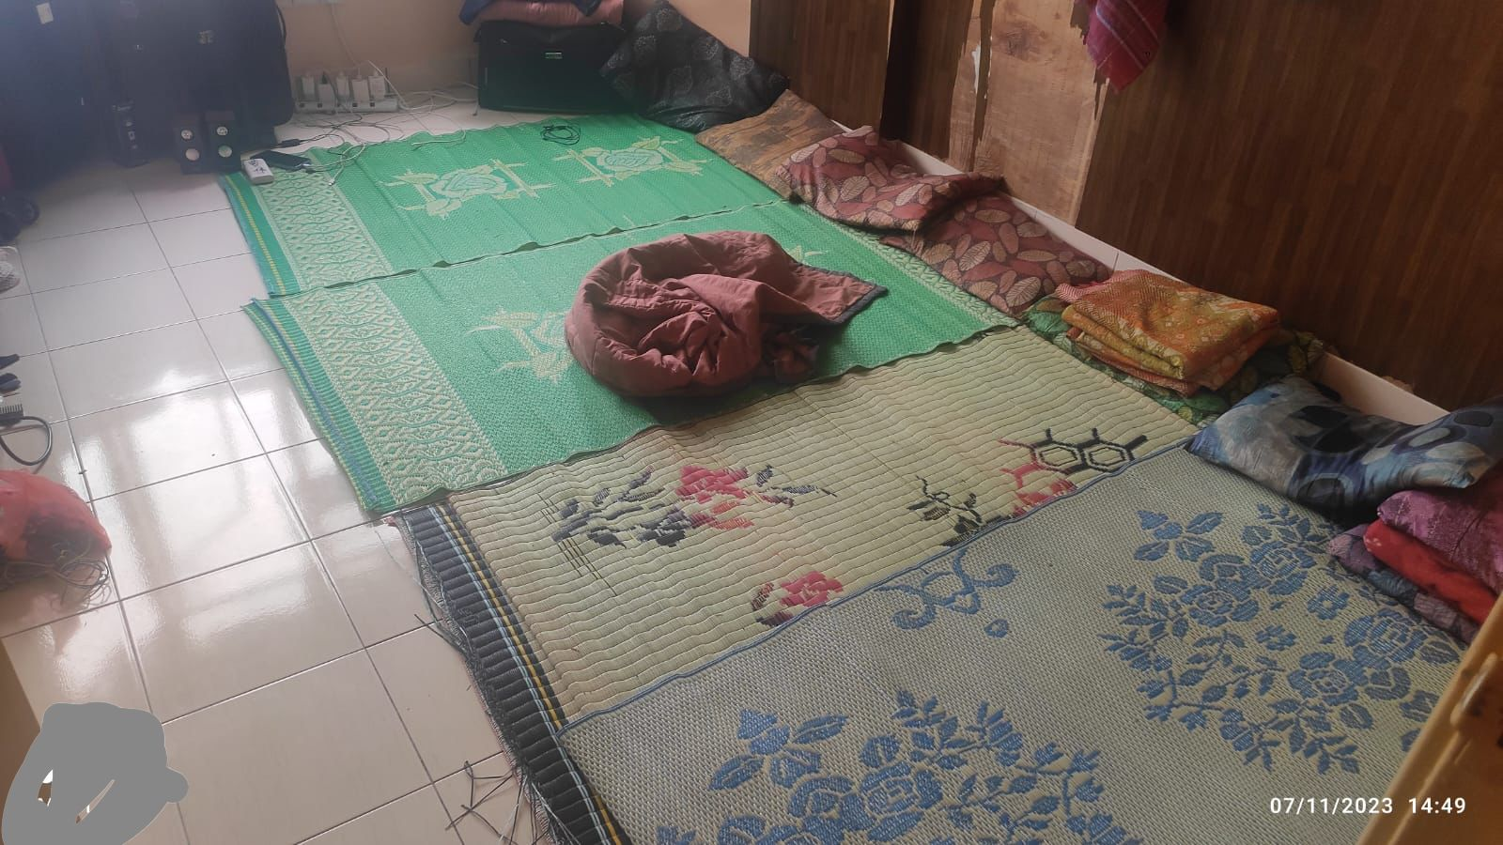
Caption: The Bangladeshi workers do not have any beds to sleep on and must sleep on the floor and the accommodation where victims of the syndicate are held and forced to stay in inhumane and unsafe conditions.

In another case, 80 workers from Bangladesh recruited by the YP Havea plantation have been waiting for jobs in a jungle since August 2023. They face various challenges in their accommodation, such as flash floods, elephant encounters, and snake attacks. Despite allegedly paying high migration costs, the promised jobs never materialize, trapping them in debt bondage. Their lives are miserable because of confiscated passports, limited access to water and food, lack of electricity, and poor sanitation. These conditions all indicate a violation of Article 5 UDHR due to cruel and degrading treatment; Article 13 UDHR, the right to freedom of movement; Article 15 UDHR, the right to a nationality; and Article 25 UDHR, the right to an adequate standard of living.

Similarly, Eluminas Engineering recruited around 100 workers from Bangladesh who remained jobless from Dec. 2022 to May 2023. They were moved without consent and promised attractive jobs within a few days, which never materialized. This led to confiscated passports, expired visas, detention due to irregular status, and then even torture in detention centers following their arrest, indicating a violation of Article 5 UDHR, Article 13 UDHR, and Article 25 UDHR. Although these workers eventually found jobs at a chicken factory. The workers faced terrible conditions with confiscated passports, significant debts, and non-payment of wages at the chicken factory. Only after continuous efforts and media attention in Bangladesh did the workers receive their salaries in September 2023, with their passports returned in October 2023 by the workforce agencies. However, they still fear wage disruptions and passport confiscation once external influences and media attention fade.

All the victims above face a violation of Article 8 UDHR, a right to an effective remedy. The Bangladeshi migrant workers lack assistance in addressing issues and resolving disputes, infringing on their right to remedy. These are just a few examples of the likely thousands of cases where aspiring migrant workers in Malaysia endure similar hardships, facing exploitation, debt bondage, and various forms of abuse. The table below highlights some individual case studies and essential information on them.

Employer and Worker Identifier | Amount Paid | Arrival date | Number of days in Malaysia vs. days work provided and salary received | Forced labour indicators: Confinement, passport retention, irregular, deception (C, P, I, D)
Suria Harmoni 1 (SH1) | Shaheen Travel 500,000 BDT  (home mortgage) | 26/8/2023 | 77 vs. 0 | C, P, I, D
SH 2 | Shaheen Travel 470,000 BDT  (home mortgage) | 26/8/2023 | 77 vs. 0 | C, P, I, D
SH3 | Shaheen Travel 500,000 BDT  (home mortgage) | 26/8/2023 | 77 vs. 0 | C, P, I, D
SH4 | Shaheen Travel 360,000 BDT  (home mortgage) | 26/8/2023 | 77 vs. 0 | C, P, I, D
SH5 | Shaheen Travel 550,000 BDT  (home mortgage) | 26/8/2023 | 77 vs. 0 | C, P, I, D
SH6 | Shaheen Travel 455,000 BDT  (home mortgage) | 26/8/2023 | 77 vs. 0 | C, P, I, D
SH7 | Shaheen Travel 550,000 BDT  (home mortgage) | 26/8/2023 | 77 vs. 0 | C, P, I, D
SH 8 | Shaheen Travel 500,000 BDT (home mortgage) | 26/8/2023 | 77 vs. 0 | C, P, I, D
Yp Havea | Hope International 400000 BDT | 20/8/2023 | 83 vs. 0 | C, P, I, D
Yp Havea | Hope International  550000BDT | 20/8/2023 | 83 vs. 0 | C, P, I, D
Magnatron Sdn Bhd | Path Finder International  450000 BDT | 30/8/2023 | 83 vs. 0 | C, P, I, D
Magnatron Sdn Bhd | Path finder International  450000 BDT | 30/8/2023 | 75 vs. 0 | C, P, I, D
Risda Plantation | Ramna Air International 420000 BDT | 30/8/2023 | 75 vs. 0 | C, P, I, D
Eluminas Engineering Sdn Bhd ;  Ayamas Food Corporation Sdn Bhd | Greenland Oversea  4,80000 BDT | 30/12/2022 | 319 vs. 203 | C, P, I, D
AECOR Innovation Sdn Bhd | Amial International  400000 BDT | 3/2/2023 | 284 vs. 60 | C, P, I, D
AMINHAQ Sdn Bhd | Celebrity International Bangladesh 450000 BDT | 14/7/2023 | 123 vs. 0 | C, P, I, D

ILO Indicators of Forced Labour
Almost all of the International Labour Organization's (ILO) 11 indicators of forced labour are present amongst Bangladeshi workers who are victims of the syndicate highlighted above, including abuse of vulnerability, deception, restriction of movement, isolation, intimidation, threats, retention of identity documents, withholding of wages, debt bondage, and abusive working and living conditions.

Forced Labour and Money Laundering
- Forced Labour
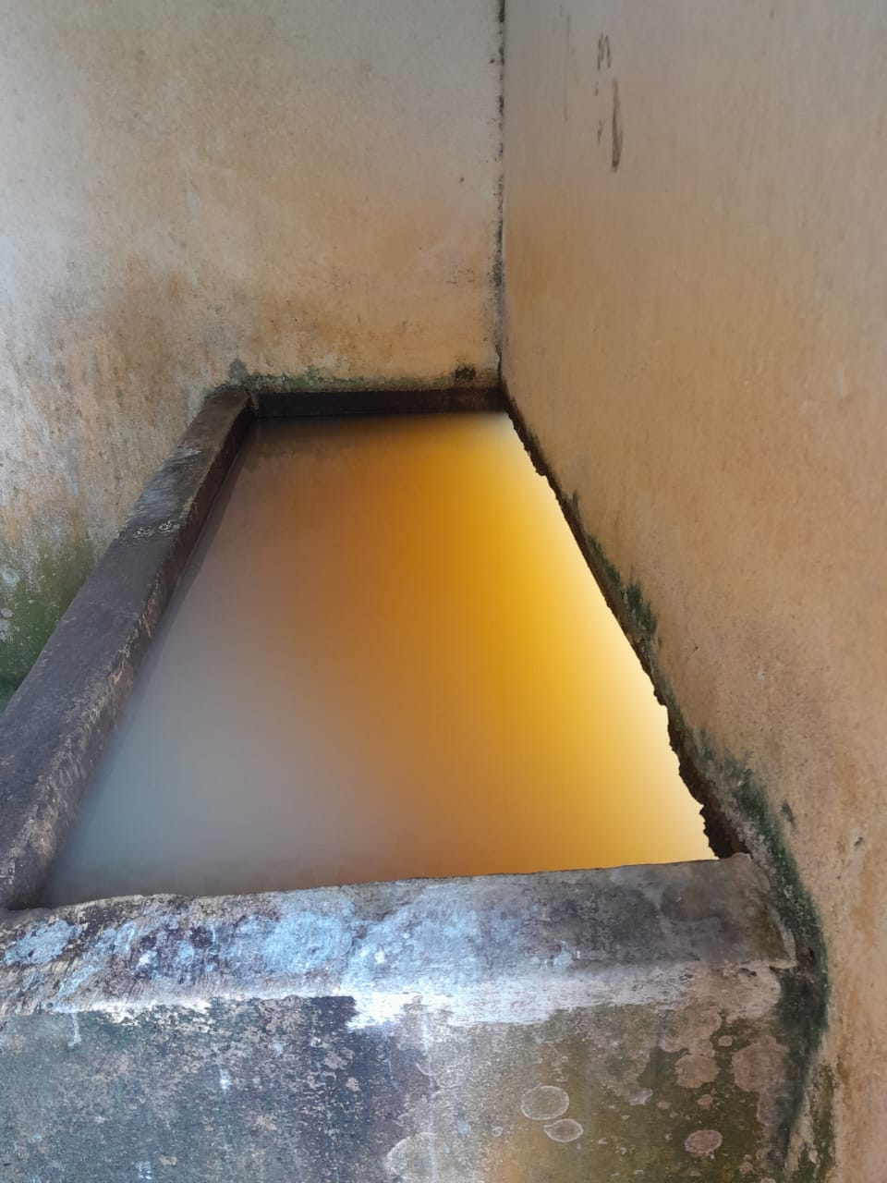
According to the ILO Forced Labour Convention, 1930 (No. 29), forced or compulsory labour is "all work or service which is exacted from any person under the threat of a penalty and for which the person has not offered himself or herself voluntarily." The Forced Labour Protocol (Article 1(3)) explicitly reaffirms this definition consisting of three elements. The situation faced by Bangladeshi workers in Malaysia can be classified as forced labour, according to the ILO Convention. These workers are subjected to threats and are unable to leave their accommodations as their passports have been confiscated by their employers, who have also relocated them to isolated areas. This creates a sense of entrapment and a lack of freedom for the workers.
Caption: This picture depicts the unsanitary and dirty water the Bangladeshi workers must drink and clean with in Malaysia.

(ii) Money Laundering (UNTOC)
The situation described above and in this briefing constitutes money laundering as defined under Article 7 UNTOC as large amounts of money extorted from Bangladeshi workers in Bangladesh are transferred irregularly to Malaysia.

Organized Crime (UNTOC)
Bogus employers in Malaysia acting as outsource agents, the Bangladesh recruiters and local Malaysian agents or intermediaries who pick up Bangladeshi workers from the airport on arrival constitute an organized criminal group as defined by the UNTOC. Malaysia signed UNTOC on September 26th, 2002, and ratified it on September 24th, 2004. State parties are legally obliged to institute regulatory measures to detect and combat money laundering by these criminal groups.

Bangladesh and Malaysia have failed to combat organized crime, given the considerable transfer of illicit funds between the various actors exploiting vulnerable migrant workers across the Bangladesh-Malaysia migration corridor. Malaysia, in particular, has done little to effectively deter corruption associated with a transnational organized crime involving foreign worker recruitment following the arrests of senior aides to Human Resources Minister V. Sivakumar by the Malaysian Anti-Corruption Commission (MACC) this year. Moreover, MACC summoned Minister V. Sivakumar on April 3rd, 2023, to aid in its investigations into alleged corruption relating to the recruitment of migrant workers.

A perception of executive bias towards nationals in general and public officials in particular would not be irrational, especially since these investigations' outcomes remain undisclosed. There is no evidence that the MACC's investigation into corruption in foreign worker recruitment will result in accountability and remediation of the victims involved.

Bangladeshi and Malaysian Government's Responses
Migrant worker rights specialist Andy Hall continues to raise multiple cases of Bangladeshi migrant workers in situations of destitution in Malaysia with the forced labour, trafficking, and labour abuse related authorities in Malaysia under the Ministry of Human Resources and Ministry of Home Affairs. These cases are also raised with the Bangladeshi Ministry of Expatriates' Welfare and Overseas Employment in Dhaka and the Ambassador of the Bangladeshi Embassy in Malaysia. These communications are copied to the International Organization for Migration (IOM), the Malaysian Trades Union Congress' Migrant Worker Resource Centres (MTUC MRC), the International Labour Organization (ILO), the US Embassy in Malaysia, the EU Ambassador to Malaysia and the UK Modern Slavery Envoy, as well as the Secretariat of Suhakam, the Malaysian human rights commission.

In his numerous emails to related authorities and organizations, Hall has requested prosecutions and fines for those allegedly involved in mistreating Bangladeshi workers. He has also urged that the fines imposed be used to compensate the affected workers. Furthermore, Hall has sought assistance in facilitating the process of changing employers for these workers without success. There is generally no response to these communications at all. However, occasionally, concerned officials make public statements about these complaints, and brokers or officials visit impacted workers, who will be moved elsewhere without informed consent and without their documents. Regrettably, there has been a tendency for officials to defer to the employers.

As a result, the migrant workers continue to suffer without any adequate remedy. Their situation is deteriorating daily, highlighting the urgent need for intervention and support from the Malaysian authorities. In response to the OHCHR complaint recently submitted in Oct 2023 by Andy Hall (below), the human resources ministry in Malaysia pledged publicly to conduct nationwide operations, but this has not been evidenced so far. This is all despite Malaysia recently publishing three National Action Plans on Forced Labour, Trafficking, and Business Human Rights, in which commitments to address exploitation and abuse of the nature outlined in this briefing document are outlined in detail.

Malaysia’s ministry of human resources recently announced it had found employment and facilitated the change of employer for around 1, 000 migrant workers in the country left stranded by their employers or agents and that some action had been taken by officials against those responsible, involving a newly created rescue committee. However, the announcement didn’t state what time period the figure referred to, how stranded workers can petition to change employer, under what powers change of employer is facilitated or allowed, and the costs involved. Likewise it doesn’t appear s90A and s90B of the Employment Act 1955, were utilised to collect fines from offenders and compensate workers, nor that any prosecution under the recently amended s90B relating to forced labour was initiated.

Complaint to OHCHR Special Procedures
In Oct. 2023, migrant worker's rights specialist Andy Hall wrote a letter raising the above issues to the OHCHR. The complaint was addressed to various bodies under the United Nations Human Rights Council (UNHRC) 's Special Procedures Unit in Geneva, including the UN Working Group on Business and Human Rights and Special Rapporteurs on Slavery, Trafficking, Migration, and Poverty. The letter was also addressed to Ms. Pia Oberoi, the OHCHR's migration representative in Bangkok. Only the UN Working Group on Business Human Rights acknowledged the complaint in a brief email, while the other special procedures units did not respond.

Non-Governmental and UN Agency Responses
Despite reaching out to organizations such as the International Labour Organization (ILO), the International Organization for Migration (IOM), the Malaysian Trades Union Congress (MTUC), as well as relevant local and regional NGOs, including the International Justice Mission (IJM), NSI and Tenaganita, until now none of these organizations have responded practically to worker's complaints. All organizations engaged have stated that they cannot assist in addressing the plight of these Bangladeshi workers in Malaysia due to a lack of resources, shelter, or other means to assist.

Recently, IOM's Migrant Worker Protection Unit requested the support of networks assisting Andy Hall to start screening the cases of Bangladeshi migrants in Malaysia, which is a positive development. This step can potentially help identify and address the issues faced by these vulnerable workers. However, it is crucial to emphasize the need for immediate action to protect and support these individuals. Lack of support further exacerbates the dire situation faced by these workers.

Challenges Identifying Victims of Human Trafficking in Malaysia
Shelters in Malaysia exist to assist trafficked individuals, supposedly offering a safe environment and access to services. However, these shelters have been criticized for violating human rights principles by forcibly detaining victims until repatriation, which can take months or even a year. Malaysia falls short of meeting minimum standards in combating human trafficking, with insufficient prosecution of traffickers and inconsistent implementation of identification procedures and victim services. Most of the vulnerable victims of abuse that are outlined in this briefing, and in most cases concerning Bangladeshi migrant workers who are destitute in Malaysia, do not want to be detained in trafficking shelters pending repatriation but want support to find meaningful employment to pay off their debt and to remediate their situations of debt bondage. They also seek the alleviation of their destitution.

Recommendations for Immediate Action
UN agencies, including ILO, OHCHR, and IOM diplomatic missions focusing on forced labour and human rights, are requested to make high-level interventions encouraging the government of Malaysia to address and remediate the plight of Bangladeshi workers outlined in this briefing, cease the ongoing perversion of the justice system and initiate prosecutions organized crime groups involved in money laundering, human trafficking, and forced labour. The OHCHR is requested to invoke interim measures under Article 5 (1) of the Optional Protocol due to the severity of the circumstances discussed here.

Report SD, ‘With 53 Bangladeshi Workers Reaching Malaysia, Labour Market Reopens after 3 Years’ (The Daily Star, 10 August 2022) https://www.thedailystar.net/nrb/migration/skilled-migration-more/news/53-bangladeshi-workers-reaching-malaysia-labour-market-reopens-after-3-years-3091356&gt.
Hasan S, ‘Labour Recruitment to Malaysia: Time to Break the Never-Ending Cycle’ (The Daily Star, 25 July 2022) https://www.thedailystar.net/opinion/views/news/labour-recruitment-malaysia-time-break-the-never-ending-cycle-3079011&gt.
Perumal E, ‘Over 100,000 Bangladeshi Workers Paid RM20K Each to Syndicate Involving “Datuk Seri” Fatcat to Work in Malaysia’ (The Star, 28 November 2019) https://www.thestar.com.my/news/nation/2018/06/22/human-traffickers-made-rm2bil-syndicate-smuggled-in-over-100000-workers-from-bangladesh/&gt; Abrar CR, ‘Syndicates in Migration: Re-Accessing the Malaysian Labour Market’ (The Daily Star, 2 June 2022) https://www.thedailystar.net/views/opinion/the-shores-injustice/news/combatting-the-syndicate-syndrome-3037171&gt.
Parkaran K, ‘We Were Protesting Malaysia’s “Syndication Plan”, Says Bangladesh Group ...’ (Free Malaysia Today, 3 June 2023) https://www.freemalaysiatoday.com/category/nation/2022/06/03/we-were-protesting-malaysias-syndication-plan-says-bangladesh-group/&gt.
Vinotha, S. ‘Full probe of migrant worker syndicate, Malaysian HR Minister Sivakumar (Malaysiakini, 22nd Nov 2023) https://andyjhall.org/2023/11/22/malaysiakini-22nd-nov-2023-full-probe-of-migrant-worker-syndicate-malaysian-hr-minister-sivakumar-says-but-nb-these-are-not-isolated-cases-its-a-systemic-issue-actually-worsening-in-mala/
Vinotha, S, Malaysian human rights (Suhakam) commissioner wants task force to probe migrant worker quota fraud (Malaysiakini, 27th Nov 2023) https://andyjhall.org/2023/11/27/malaysiakini-26th-nov-2023-malaysian-human-rights-suhakam-commissioner-wants-task-force-to-probe-migrant-worker-quota-fraud/
Ananthalakshmi A and Latiff R, ‘Malaysia Probes Cases of Migrant Workers Left Jobless, without Passports’ (Reuters, 20 April 2023) https://www.reuters.com/world/asia-pacific/malaysia-probes-cases-migrant-workers-left-jobless-without-passports-2023-04-20/&gt.
Report SD, ‘Govt Sets TK 78,990 Max Migration Cost in Bangladesh for Workers Going to Malaysia’ (The Daily Star, 7 July 2022) https://www.thedailystar.net/nrb/migration/news/govt-sets-tk-78990-max-migration-cost-bangladesh-workers-going-malaysia-3066141?amp.
Parkaran K, ‘Activist Refers Stranded Bangladeshi Workers’ Plight to UN Rights Body ’ (Free Malaysia Today ,30 October 2023) https://www.freemalaysiatoday.com/category/nation/2023/10/30/activist-refers-stranded-bangladeshi-workers-plight-to-un-rights-body/&gt.
Migrants in Malaysia: Hundreds Left Stranded in Recruitment Scam (Al-Jazeera, 10 July 2023) https://www.youtube.com/watch?v=N2hlQi5_yLY&gt.
Hall A, ‘FMT 20th Sep 2023: Rate of Abused Bangladeshi Workers’ Entry into Malaysia Worrying, Says Migrant Rights Activist Andy Hall’ (20 September 2023) https://andyjhall.org/2023/09/20/rate-of-abused-bangladeshi-workers-entry-into-malaysia-worrying/&gt.
Hall A, ‘19th Oct 2023: Malaysia Facing Huge Excess of 1/4 Million Migrant Labourers’ https://andyjhall.org/2023/10/19/malaysia-facing-huge-excess-of-1-4-million-migrant-labourers/&gt.
Maliamauv JP, ‘Migrant Workers Are Not Expendable Units of Production’ (Malaysiakini, 13 March 2019) https://www.malaysiakini.com/letters/467808.
An estimated 90 Bangladeshi workers hired by Eluminas Engineering in Malaysia suffered joblessness, passport confiscation, and mistreatment. After securing jobs at Ayamas Food Corporation, they endured three months of unpaid wages. Through many efforts and media reports initiated by Andy Hall, the workers started recieved salaries in September 2023 and resolved payment and passport issues in October 2023.
AECOR Innovation workers faced unemployment from February 2023 to May 2023. They secured a four-month job from May 24th 2023 to June 24th 2023 at KLIA but only received one month's salary. The Bangladesh Embassy covered another month's basic salary. Currently, the workers are without employment, anticipating their next jobs.
International Labour Organization (ILO), Forced Labour Convention, C29, 28 June 1930.
The forced labour definition encompasses "traditional practices of forced labour, such as vestiges of slavery or slave-like practices, and various forms of debt bondage, as well as new forms of forced labour that have emerged in recent decades, such as human trafficking" also called "modern-slavery."
(i) Work or service refers to all types of work occurring in any activity, industry, or sector, including in the informal economy. (ii) Menace of any penalty refers to a wide range of penalties used to compel someone to work. (iii) Involuntariness: The terms "offered voluntarily" refer to the free and informed consent of a worker to take a job and his or her freedom to leave at any time.
According to the United Nations Office on Drugs and Crime (UNTOC) Article 7, money laundering is the processing of criminal proceeds to disguise their illegal origin. This process is critical, enabling the criminal to enjoy these profits without jeopardizing their source.
According to UNTOC Article 2(a), organized crime is a criminal enterprise that rationally works to profit from illicit activities, often in great public demand. Its continuing existence is maintained through the corruption of public officials and the use of intimidation, threats, or force to protect its operations. Organized crime is considered a structured group of three or more persons. The group has existed for some time. It acts in concert to commit at least one serious crime and obtain, directly or indirectly, a financial or other material benefit.
Tan B, ‘Report: MACC Arrests Another Senior Aide to Human Resources Minister’ (Malay Mail, 14 April 2023). https://www.malaymail.com/news/malaysia/2023/04/14/report-macc-arrests-another-senior-aide-to-human-resources-minister/64801&gt.
Iskandar Ibrahim M, ‘MACC Takes Statement from Human Resources Minister over Migrant Worker ...’ (The Straitis Times, 16 April 2023) https://www.nst.com.my/news/nation/2023/04/900198/macc-takes-statement-human-resources-minister-over-migrant-worker&gt; ‘Macc Nabs HR Minister’s Officer over Alleged Graft in Migrant Worker Hiring’ (The Vibes, 13 April 2023) https://www.thevibes.com/articles/news/90293/macc-nabs-hr-ministers-officer-over-alleged-graft-in-migrant-worker-hiring&gt.
‘AG’s report: HR, Home ministries must decide who takes full ownership of Malaysia’s foreign worker management system’ (Benarma, 24th November 2023) https://andyjhall.org/2023/11/24/24th-nov-2023-bernama-ags-report-hr-home-ministries-must-decide-who-takes-full-ownership-of-malaysias-foreign-worker-management-system-my-comments/
‘Sivakumar Pledges Action on Plight of Stranded Bangladeshi Workers’ (Free Malaysia Today, 5 November 2023) https://www.freemalaysiatoday.com/category/nation/2023/11/05/sivakumar-pledges-action-on-plight-of-stranded-bangladeshi-workers/&gt.
‘More than 1,000 foreign workers given job placements under new employers, says HR Ministry’ (Star, 25th November) https://www.thestar.com.my/news/nation/2023/11/25/more-than-1000-foreign-workers-given-job-placements-under-new-employers-says-hr-ministry
H B A Hamid, ‘Shelter Homes – Safe haven or prison?’, Anti-Trafficking Review, issue 20, 2023, pp. 111-134; U.S Department of State, ‘2023 Trafficking in Persons Report: Malaysia’ (U.S. Department of State, 16 October 2023) https://www.state.gov/reports/2023-trafficking-in-persons-report/malaysia/&gt.
The Protocol to Prevent, Suppress and Punish Trafficking in Persons, Especially Women, and Children, Supplementing the United Nations Convention against Transnational Organized Crime defines the term "trafficking in persons" under Article 3, “use of terms” as follows: (a) "Trafficking in persons" shall mean the recruitment, transportation, transfer, harboring, or receipt of persons by means of the threat or use of force or other forms of coercion, or abduction, fraud, deception, or the abuse of power, or of a position of vulnerability or of the giving or receiving of payments or benefits to achieve the consent of a person having control over another person, for the purpose of exploitation. Exploitation shall include, at a minimum, the exploitation of the prostitution of others or other forms of sexual exploitation, forced labour or services, slavery or practices similar to slavery, servitude, or the removal of organs; (b) The consent of a victim of trafficking in persons to the intended exploitation set forth in subparagraph (a) shall be irrelevant where any of the means set forth in subparagraph (a) have been used.

